**Problem Statement**

**Product Dissection for top leading Platforms**

Welcome to this case study on dissecting and designing products for top leading platforms. In this case study, you will delve into the intriguing world of schema design for a prominent platform of your choice. Your task is to choose a top leading platform, research its features, and meticulously craft a schema design that encapsulates the essence of its functionality. By focusing on key entities, attributes, and relationships, you will gain invaluable insights into how data architecture drives the platform's effectiveness.

**Step 1: Choose a Leading Platform**

Select a leading platform of your choice, which could span various domains such as social media, e-commerce, finance, or any other industry. This choice will form the foundation of your exploration into its schema design.

**Step 2: Research:**

Thoroughly research the platform you have selected. Investigate its core features, functionalities, and user interactions. Identify the top features that define its user experience and contribute significantly to its popularity.

**Step 3: Product Dissection and Real World Problems solved by the platform**

In this step, you will meticulously analyse the platform's standout features and how they provide innovative solutions to real-world challenges. By identifying key functionalities that resonate with users, you'll unravel how the platform effectively addresses problems and enhances user experiences. This dissection will serve as the foundation for understanding how the schema design aligns with the platform's core objectives.

**Step 4: Case Study on the real world problems and approach to solving them**

In this pivotal step, you will expand on the real-world challenges uncovered in Step 3 through a comprehensive case study. Delve into specific instances where users encountered difficulties and showcase how the platform's unique features provided effective solutions. By dissecting the approach taken by the platform to overcome these challenges, you'll gain a deeper appreciation for the platform's user-centric design philosophy and how it shapes the schema design.

**Step 5: Schema Design Based on Top Features**

Based on the features you have identified, craft a schema design that reflects the platform's data structure. Focus on the key entities, attributes, and relationships that underpin the chosen features. Your schema should capture the essence of how the platform organises and utilises its data.

**Step 6: Rationale Behind the Design**

While creating the schema design, consider the rationale behind the platform's choices. Reflect on why certain entities and relationships were chosen and how they align with the platform's goals. This will help you understand the strategic decisions driving the schema's architecture.

**Step 7: Create an ER Diagram**

Utilise tools like the Miro platform or similar applications to create an illustrative Entity-Relationship (ER) diagram. This diagram should vividly depict the entities, attributes, and relationships present within your schema design. The ER diagram will serve as a visual representation of your insights.

**Step 8: Presentation of Findings**

Present your findings in a clear and concise manner. Showcase your understanding of how the schema design impacts the platform's functionality and user experience. Explain how your chosen features are integrated into the schema and how the schema's structure supports the platform's objectives.

**Task Details:**

1. **Answer Submission:** Your submission should include well-structured solutions for all provided questions related to product schema designs.
2. **Video Creation:** Create an informative and engaging video where you thoroughly explain the Case Study.
3. **Depth and Clarity:** Ensure your solutions are detailed and showcase your understanding of product schema design principles. Similarly, in the video, provide clear explanations that are easy to understand for a wide audience.
4. **Creativity Encouraged:** You are welcome to utilise visuals, diagrams, or creative elements to enhance the clarity and impact of your explanations.

**Note:**

1. Duplicate this document and proceed to write your solutions and prepare your video.
2. Include the video link in this document before final submission.

Best of luck in completing this project and showcasing your prowess in dissecting and designing product schema for leading platforms! **For reference, we have also conducted a case study on Instagram, which you can find below. This case study will provide you with valuable insights into how schema design plays a pivotal role in shaping the functionality and success of a prominent platform.**

**Product Dissection for Facebook**

### **Company Overview:**

Facebook was founded in 2004 by Mark Zuckerberg and his fellow Harvard College students and roommates.

Eduardo Saverin, Andrew McCollum, Dustin Moskovitz, and Chris Hughes.The company is headquartered in Menlo Park, California.As of my last knowledge update in August 2023, Facebook had over 3.03 billion monthly active users, making it one of the largest and most influential tech companies in the world.it has played very Important role in shaping the way people connect and communicate online.Facebook has a mission as 'With a mission to "bring the world closer together'.

### **Product Dissection and Real-World Problems Solved by Facebook:**

Facebook is a big player in the world of social media, and it's not only for making friends. But also for a while has been great at connecting people worldwide. It's like a place where we can talk, share stuff like words, pictures, and videos, and do more with features like posting updates and reacting to posts. Basically, it helps us express ourselves and talk to others in this digital age.

Facebook is the thing that helps us interact with stuff, like clicking 'Like,' leaving comments, and sharing posts with each other. These things changed how we use the internet. And when there's too much stuff to see, Facebook helps by showing us the important stuff first. It's like having your own news channel ,pages. It makes sure we see new posts and things we care about. Facebook is a way of dealing with too much stuff online only.

Although facebook is not only useful for just connecting people but also for businesses .They have their own Facebook pages and communities.they use the facebook pages for marketing purpose for showing their product to the right people by showing them ads of the particular product.it is a very good way to expand the business.

Hence facebook is not just for only making friends but it also the to make the online world more friendly and easy to understand and useful.it is like a place where we connect to people, share the images,video,learn something new about anything and both in our personal lives and for work as well.it is also useful for keeping Better to fit what we need.it is not just the part of the internet but also used for helping to shape how we use it.

### **Case Study: Real-World Problems and Facebook’s Innovative Solutions**

The contributions of various researchers on Facebook are shown in the table above. The rise of technology and the global expansion of the internet have both aided in the widespread use of social networking sites. The constant increase in users was influenced by an increase in smartphone users, reduced internet pricing, and other factors. The review focused on empirical publications about Facebook that were published in scholarly journals or publications.

#### **Problem 1: Give access to public to see the world**

**Real-World Challenge:** A real world problem is the lack of access to the global digital landscape for many individuals, particularly in remote and underserved areas. Limited internet connectivity and the digital divide prevent millions of people from accessing essential information, educational resources, and opportunities available on the internet. As a result people can not see the entire world thoroughly.

**Facebook's Solution:**

Facebook resolve this problem by accessing initiatives like Internet.org.this help to provide free access to internet Services ,including facebook in the underserved and remote areas.by doing this facebook help to access curated a set of online resources, including educational content, health information, and communication tools, Facebook's Free Basics helps bridge the digital divide and allows more people to connect with the broader world and its opportunities, even in areas with limited internet infrastructure.

#### **Problem 2: Online Learning and Education**

**Real-World Challenge:** A real world problem came in when the COVID-19 pandemic came that is disrupted.traditional education systems worldwide.this problem also disrupted students as well.

**Facebook's Solution:**

To address this, Facebook introduced several initiatives and resources to support educators, students, and online learning platforms like Facebook for Education,Partnerships with Educational Organization,Donation Matching for Education,Support for Small Businesses in Education.These initiatives demonstrated Facebook's commitment to facilitating online education and ensuring that individuals, regardless of their location or circumstances, have access to quality learning opportunities through its platform.

#### **Problem 3: Communication**

**Real-World Challenge:** When Facebook is not launched the communication occurs through email and chat rooms only so users only Have very limited access to communicate one after another.

**Facebook's Solution:**

To address this issue facebook innovated a feature in facebook called the wall and newsfeed.with the help of this . It is easy to share updates of anything ,sharing images,videos with the help of their real time network.Instead of having to visit individual profiles to see updates from friends, the News Feed aggregates posts from friends, groups, and pages a user follows into a single, continuously updating stream.These features contributed to Facebook's rapid growth and its status as a dominant player in the social media landscape.

#### **Problem 4: Lack of a Networking Platform**

**Real-World Challenge:** Before the introduction of Facebook's networking , people faced challenges in both connecting with others and finding like-minded individuals online.so they basically have a very limited amount of connectivity and it is only restricted to some areas.

**Facebook's Solution:**

Facebook introduced a comprehensive profile system that encouraged users to add details about their schools, workplaces, and interests. This enabled users to find and connect with individuals they had common affiliations with, whether it be former classmates or colleagues. This information-rich profile system made it easier for users to discover and reconnect with old friends, and it also helped in professional networking

#### 

#### **Conclusion:**

Facebook revolutionised online communication, networking, and community building by introducing innovative solutions to address real-world problems.Facebook has demonstrated a commitment to addressing real-world problems throughout its evolution. From its early days as a social networking platform to its current focus on the metaverse and beyond, Meta has tackled numerous challenges and devised innovative solutions. This case study shows how user-centric ethos and unwavering commitment to pushing the boundaries of technological innovation. By focusing on user needs and preferences, Facebook has not only maintained its leadership in the social media domain.

### **Top Features of Facebook:**

1. **The like button:** Before the Like button, to approve of another person's post, you had to write, "Like" or, "Yeah!" or, "Wow, I like that too LOL!" Those were dark times.but after facebook introduced a feature like people hit the like button whenever they like the photos or video this saves the time of the people Instead of writing the comment.
2. **Events:** The next Facebook feature you should be thankful about is ‘Events’. This feature lets you know what is going on in the current social life. You can get your family and friends together by creating an event on Facebook which will let everyone know about something that is going to take place in the near future.
3. **Filter Content**: The ability to ‘Filter Content we see’ is the next best feature of this social media app. With this feature you can unfollow certain posts and block ads. It also helps you to put your friends in priority . This feature works on how often you interact with a friend, page or public figure, how many likes, shares and comments an individual post has received, how much you interacted with such a post in the past and whether it’s being hidden or reported a lot.
4. **Save post for later:** ‘Save post for later’ is Facebook’s next useful feature. On Facebook it is next to impossible to go back and find something that you missed watching while scrolling in a hurry. This feature does not let you lose the post of your interest as you can save it to watch later. Notably the saved post does not expire but if the original poster deletes the post it might disappear from your saved folder.
5. **Photos:** ‘Photos’ are the most popular feature of Facebook. People use it to share their photos and videos with friends and family. The best part of this feature is that when you post any picture on Facebook a copy of it is stored on Facebook’s global servers so it can be retrieved anywhere and anytime which means you will never lose your precious moments.
6. **Messenger:** The best Facebook feature is the ‘Facebook Messenger’. This helps you to connect with your dear and near ones. Though it is just like any other chat platform, now it comes in the top 75 most downloaded apps.

### **Schema Description:**

Facebook's schema comprises a multitude of entities that comprehensively represent the platform's dynamic landscape.These entities include User Profiles, Posts, Comments, Reactions, Friendships, Pages, Groups .

**User Entity:**At the heart of Facebook lies its foundation, the User entity, which serves as the repository for comprehensive user information. This entity houses vital details about each individual utilising the platform.

* **UserID (Primary Key)**: A unique identifier for each user.
* **First Name**: The first name of the user.
* **Second Name**: The second name of the user.
* **Username**: The chosen username for the user's account.
* **Email**: The user's email address for account-related communication.
* **Date of Birth**: The user’s date of birth.

**Friendship Entity:**

Friendships define connections between Facebook users:

* **FriendshipID (Primary Key):** A unique identifier for each friendship relationship.
* **User1ID (Foreign Key referencing User Entity**): One of the users involved in the friendship.
* **User2ID (Foreign Key referencing User Entity**): The other user involved in the friendship.
* **Friendship_Date**: The date when the friendship was established.

**Event Entity:**

Events represent gatherings and activities organised on Facebook:

* **EventID (Primary Key)**: A unique identifier for each event.
* **UserID (Foreign Key referencing User Entity)**: The user creating or hosting the event.
* **Event_Name**: The name or title of the event.

**Page Entity:**

Pages are created for businesses, organisations, or public figures:

* **PageID (Primary Key):** A unique identifier for each Facebook page.
* **AdminUserID (Foreign Key referencing User Entity):** The user who administers the page.
* **Page_Name:** The name of the Facebook page.
* **Page_Category:** The category to which the page belongs (e.g., business, entertainment).
* **Creation_Date:** The date when the page was created.

**Message Entity:**

Messages facilitate private conversations between Facebook users.

* **MessageID (Primary Key)**: A unique identifier for each message.
* **SenderUserID (Foreign Key referencing User Entity)**: The user sending the message.
* **ReceiverUserID (Foreign Key referencing User Entity)**: The user receiving the message.
* **Message_Text**: The text content of the message.

**Group Entity:**

Groups are created for users to collaborate, discuss, and share within specific communities:

* **GroupID (Primary Key):** A unique identifier for each Facebook group.
* **CreatorUserID (Foreign Key referencing User Entity):** The user who created the group.
* **Group_Name:** The name of the Facebook group.
* **Group_Description:** A description of the group's purpose and rules.
* **Creation_Date:** The date when the group was created.

**Relationships are:**

* **Users make Friendship with other people :**- Each user can create multiple friends.
* **Users create Events :-** Each user can create multiple events.
* **Users create Pages:-** Each user can create multiple Pages
* **Users massage another person:-** Each user can massage multiple people .
* **Users create Groups:-** users can create multiple Groups.

**ER Diagram:**

Let's construct an ER diagram that vividly portrays the relationships and attributes of the entities within the Facebook schema. This ER diagram will serve as a visual representation, shedding light on the pivotal components of Facebook’s data model. By employing this diagram, you'll gain a clearer grasp of the intricate interactions and connections that define the platform's dynamics.

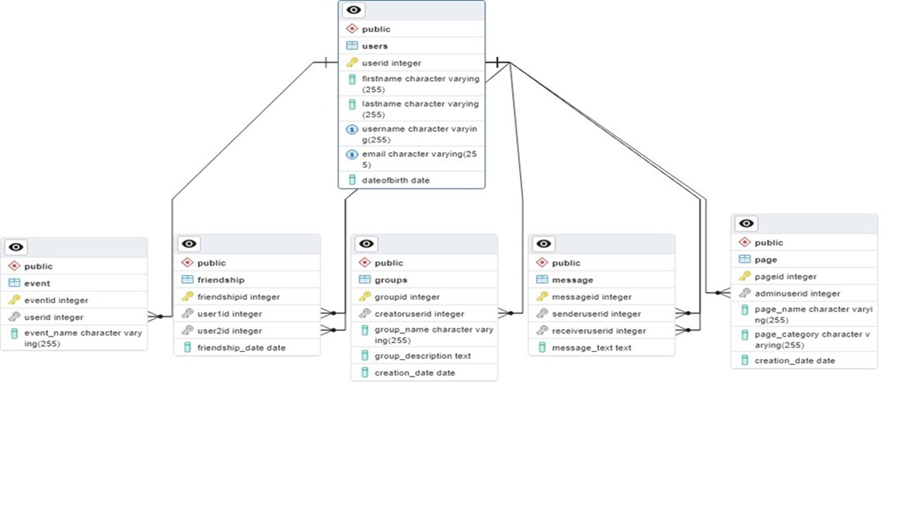

**Conclusion:**

In the case study we create the Entity-Relationship diagram along with a schema for Facebook. In case study we divide the Facebook schema and Relationship diagram. Facebook has transformed the landscape of social networking, reshaping the way people connect and communicate online. The platform's robust data model encompasses key entities such as users, friendships, pages, events, messages, and groups, all playing integral roles in shaping the platform's rich user experience.